1. Create multiply, division, subtraction function with arrow function/fat arrow

Code:

Result:



1. Create a employee object and display its data in console (for...in).

Code:

Result:



3. Use Array helper functions

a. Check if all the property values(firstName) in an array of object is same or not

array of object

[{ firstName: 'alina', id: 1, age: 14},

{ firstName: 'harry', id: 2, age: 15}, { firstName: 'alex', id: 3,age: 16}]

Code:

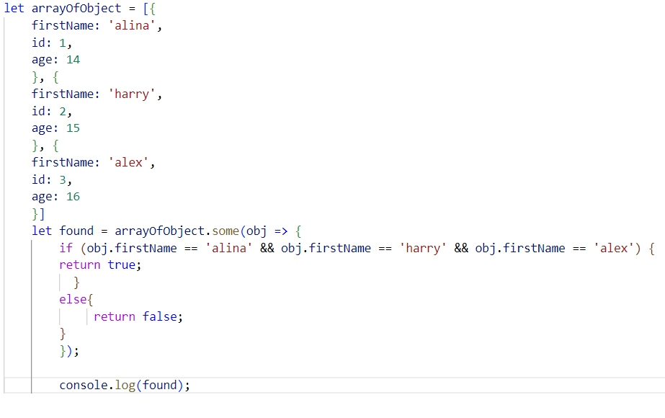

Result:



b. Get the value of the first element in an array that has value greater than 20

Code:

Result:



c. Get the value of the first element in an array that has value less than 20

code:

Result:



d. Filter data based on a id(property) in an array of objects: pick any random id value

Code:

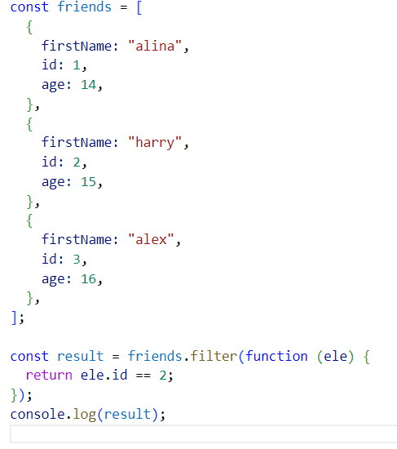

Result:

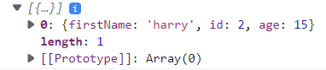

e. Round off all the decimal numbers in an array and sum all the values [9.8, 9.7, 4.5, 3.4]

Code:

Result:



f. Get all the person name based on age greater than and equal to 18, eligible to vote

[{firstName: 'joe', age: 24}, { firstName: 'alina', age: 12},{ firstName: 'alex' ,age: 20}]

Code:

Result:

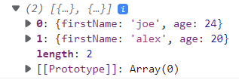

g. Sum all the elements of an array [90, 89, 56, 45]

code:

Result:



h. Check element is odd or even in an array [90, 89, 56, 45]

Code:

Result:



i. Sum of all the salaries and display final sum value:

[{salary: 56000, },{ salary: 90000}]

Code:

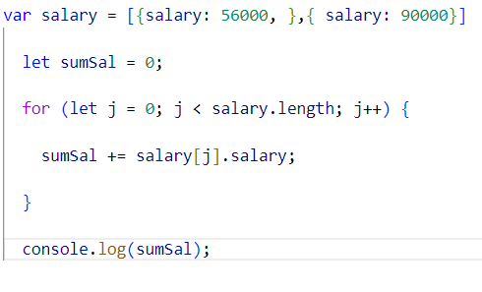

Result:



j. Concat all array elements ['red', 'pink', 'orange', 'red']: 'redpinkorangered'

Code:

Result:



,